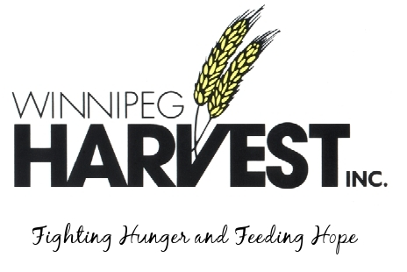

January 5, 2011

Manitoba UNIX User Group
Attn: Adam Thompson

Dear Friends of Harvest,

We here at Winnipeg Harvest want to thank the Manitoba UNIX User Group for your support of helping those less fortunate in our community. Over the last few months 743 pounds of food was donated to the food bank.

Your donations will go into hampers that will help Winnipeg Harvest feed more than 58,000 people each month, half of those being children. On behalf of the entire team at Winnipeg Harvest, thank you for helping us fight hunger and feed hope in Manitoba.

We look forward to working with you again in the future. If I can ever be of assistance, please don’t hesitate to contact me by phone at 982-3670 or by email at tori@winnipegharvest.org.

Yours truly,

Tori Webber
Development Associate
Winnipeg Harvest Inc.

